**Detail breakdown of the cost of injection molding for businesses**

# Introduction

Injection molding is an old, effective, and one of the leading processes involved in manufacturing the complex product. It enables the mass production of complex shapes with high efficiency and optimum costs. It’s a widely implemented technique of the manufacturing process, and integral to the production of products in our daily life. The injection molding enables production of the large numbers of parts with greater accuracy and in a short time from the multi-cavity tools. It involves the process of heating the polymer materials and then injecting the melted molten materials into the mold under high pressure. The injection molding is a process with high repetitions, which means that all the products produced will be identical i.e., convenient for the consistent production and in large volume. This fast and intensive process involves high pressure and heat for the injection of the molten materials. It uses popular materials like thermoplastics (ABS, PS, PE, PC, PP or TPU). It is a complex process with many variables which impact the overall expenditure of the project. Factors like the complexity of the mold design, type of material used, volume produced, and geographic conditions make the injection molding complex. The businesses of the competitive market of today’s era need efficient and consistent cost implementation in their market, which shows that knowledge of injection molding is paramount. This article focuses on the wide world of injection molding costs, providing a detailed breakdown that enables businesses to make the right decision and optimize their production processes.

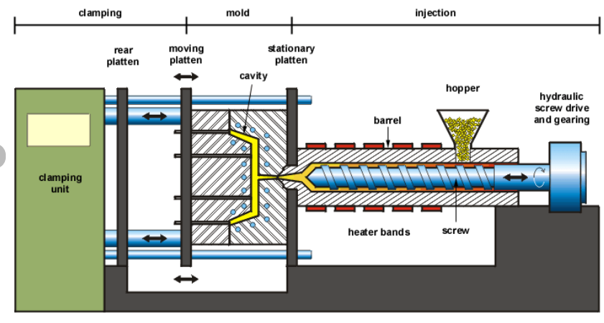

Figure 1 Schematic diagram of the typical injection molding machine.

# Fixed Costs in Injection Molding

Fixed costs of injection molding involve various components that are consistent and do not change with the production level over a period. There are multiple cost drivers for injection molding, out of which the fixed costs are the one that influences the other cost as well. Moreover, the overall financial feasibility of the injection molding is determined by the fixed costs.

Fundamentally, machinery cost plays a significant role in fixed expenses. Injection molding requires specialized machinery equipment, which involves considerable initial investment. The cost required for the purchase and maintenance of the injection molding machine must be considered in the fixed cost. The complexity and capabilities of the machines significantly make the machine's price different in the market. The machine required for a certain firm should carefully consider its production requirements and budget capacity to select the most suitable machines to mitigate long-term costs. The machine for injection molding ranges from smaller desktop injection molding machines suitable for the in-house business to large industrial injection molding machines that are utilized by large manufacturers. The production of low volumes of parts by injection molding is most effective with desktop injection molding machines and its cost varies around $350-$500. The large production requires large industrial injection machines which cost anywhere from $50,000-$200,000. These large machines require skilled labor, maintenance, and monitoring.

Secondly, facility costs are another component of the fixed costs in injection molding. Facility costs generally refer to the expenses associated with the utilities, infrastructure, rental facilities, and space required for the injection molding facility to be operated. The facility costs are driven by the size and location of the injection molding area. Although the size and location differ for different firms it will be a fixed cost for each firm. There are some mostly considerable facility costs which are rent, utilities i.e., electricity, water, etc., suitable environment conditions, timely maintenance and repairs, security, property taxes, and many more. These all-facility costs differ for different places.

Next, the labor cost is also the part of the fixed cost. But, most of the part of injection molding relies on automation. The process involved in injection molding i.e., CNC machining is operated by Computer Numerical Controlled software, while 3D printing is operated by its software, and also relies on characteristics of the CAD design to produce the mold, EDM machine also runs automatically and further the injection molding also possess automated process. So, the labor costs involved in injection molding are listed below:

* **Setup costs**

The setup labor cost comprises all the time taken by the labor to configure the equipment to manufacture the mold and finalized product. For example, while making the molds, some setup of tooling is required which involves the operator’s time.

* **Repair costs**

As injection molding is the mechanical process consisting the various mechanical and electrical equipment, it involves repair and maintenance which requires labor.

* **Monitoring costs**

Although all the processes involved in injection molding are automized, there are equipment operators who are focused on monitoring the injection molding processes to ensure quality and inventory control.

While producing the product in-house, these all costs are calculated into labor costs. The wage cost for the labor varies with location but will remain the part of fixed cost for the injection molding industry. Furthermore, the method of cost estimation for the labor costs in injection molding is simplified below:

1. Determining the number of operators required for the company.
2. Calculating the labor working hours.
3. Determining the labor rate per hour.
4. Calculating the total labor costs

Lastly, the licensing and compliance costs are crucial for injection molding. Injection companies must address the requirements of the concerned authorities and claim the license and all the required permits to operate the injection molding industry legally. The licensing and compliance come under the fixed costs considering the costs of business license, quality standard compliances, environmental permits, insurance, legal and consulting fees, taxes, occupational safety and health administration compliances, registration of the company, etc. Moreover, the consent to establish and consent to operate requires all the mentioned documents which fees are fixed for the injection molding industry.

# Variable Costs in Injection Molding

Variable costs in injection molding consist of different essential factors that ultimately impact the overall cost of production. The factors mentioned for the variable cost includes all the material cost, energy consumption,

Materials cost is one of the active elements of the variable costs in injection molding. The type and amount of the materials used in the injection molding determine the production cost. The raw material cost is the sum of the cost of storage, the cost of labor used, the loss of interest in capital, etc. There are widely used varieties of plastic used for injection molding whose use depends on the requirements of the final parts, including ABS, PS, PE, PC, PP, or TPU. The cost required for the purchase of the materials for the molds depends on the material chosen. For example, if we use high-grade plastic resin, it will increase the material cost but will result in a quality product. The material cost is determined by the model’s design, the material for molding chosen, and the amount of materials required for the injection molding process.

Energy consumption by the injection molding process is also one of the crucial element variable costs. It is the amount of energy required to convert the raw materials into the product, which requires a sufficient amount of energy to heat the molds and inject the material. The energy consumption differs with different factors and cost also varies with the change in energy consumption. Energy consumption management is a key element in managing the efficient cost of injection molding. As an example, applying the optimized heating systems and automatically switching off the heating in idle conditions will reduce energy consumption further the cost will be reduced. Furthermore, different elements will help to estimate the cost of the energy consumption in injection molding i.e., machine size and efficiency, total running time, resin type, heating and cooling, energy rates, production volume, etc. The energy consumption cost of the injection molding can be calculated using the following relation

The energy consumption data are gathered from all the appliances used in injection molding and then multiplied with the energy rate to calculate the energy cost.

Maintenance cost is another key element in the variable costs of injection molding. The equipment of the injection molding requires monitoring and timely maintenance for the efficient running of the machine. Regular maintenance, cleaning, lubrication of the parts, monitoring of the system, and replacement of the parts are the main components to bear the maintenance cost. The timely maintenance will help to reduce the maintenance cost and reduce the overall cost. However, lack of maintenance will lead the machine to breakdown and costly downtime and also lead to production delays.

Overhead costs consist of various indirect expenses that do not deal with the production part which include labor, rent, depreciation cost, insurance, and general and administrative costs but that are still part of the injection molding process. For the support in the operation of injection molding, a company may have to allocate a portion of its office space and administrative staff salaries, and these overhead costs contribute to the overall variable cost of injection molding.

# The Cost of Mold Design and Tooling

The complexity and material of mold are the driving factors in the cost of injection molding. The creation of the mold and development of the product through the injection molding is of complex process. Different factors cause the complexity in injection molding like material selection, mold design, mold fabrication, tooling maintenance, part design, environment, and many more. The certain complexity that arises in the mold is listed below:

* Part size and geometry
* Cavity design
* Mold size
* Texture and surface finish
* Tolerance and precision
* Part volume and cavities

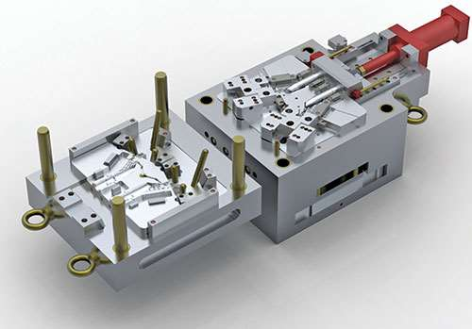

Figure 2 Pictorial representation of the complex mold design.

Similarly, there are different materials of the mold. The selection of the right mold material for the material will play a crucial part in the completion of successful injection molding material. Factors like heat resistance, wear resistance, corrosion resistance, cost, and thermal conductivity of the mold material play important roles in the selection of the right mold materials for injection molding. The materials used for the injection molds include the following

* Tool steel: Steel like P20, H13, and S136 are the tool steel that is used for mold in injection molding. These tool steels are generally used for the applications of small to large volumes.
* Stainless steel

The steel of grade 420 and 440C is used as the mold material when there is concern about corrosion resistance. They are known for their good polishing properties and can result in a smooth surface finish.

* Aluminum

Aluminum molds are often used for the low-volume production of applications as well as for rapid prototyping. The properties of aluminum like good thermal conductivity, and faster cooling sound good but the low durability and shorter lifespan lead to limiting it to rapid prototyping.

The material commonly used for injection molding is thermoplastic materials due to their unique features and are listed below with their unique features and cost:

Table 1 Thermoplastic injection molding material with their features.

|  |  |  |  |
| --- | --- | --- | --- |
| Materials | Features | Applications | Cost (per kg) |
| Acrylonitrile Butadiene Styrene (ABS) | durable, lightweight | keyboards, phone hardware, LEGO bricks, drainpipe systems, kitchen appliances | $1-$3 |
| Polyethylene (PE) | flexible, impact-resistant, leech-resistant, moisture-resistant, recyclable | food packaging, milk jugs, toys | $4.5-$8.5 |
| Polypropylene (PP) | leech-resistant, flexible | Tupperware, kiddie pools, toys, utensils, car batteries | $1.20-$1.30 |
| Polystyrene (PS) | warp, shrink, and impact resistant | compact disc cases, packaging applications, household appliances | $0.78-$2.98 |
| Nylon/ (POM) | heat-resistant, durable | high-ware parts, quick-release buckles, gears, hand cranks | $2.50-$4.00$ |
| Acrylic | Optical clarity, chemical resistant | tinted tubes, lab equipment, medical products, sports equipment, industrial components | $2.00-$2.50 |
| Polycarbonate | impact resistant, optical clarity, vulnerable to chemicals | automobile headlights, bulletproof glass, eyeglasses, greenhouses, DVDs, mobile phones | $1.5-$2.80 |
| **Thermoplastic Polyurethane (TPU)** | elasticity, transparency, resistances, tensile and tear strength | mobile phones as well as keyboard protectors and footwear | $1.08-$3.01 |
| **Thermoplastic Rubber (TPR)** | chemical and weather resistance and high-impact strength | wires and cable insulation and other applications such as home appliances, fluid dispensers, flexible hoses, catheters | $2.00-$4.00 |

Next, the mold design is the part to determines how the final product looks, and a design fee is a must for the mold designer. For a successful molding project, it requires a good mold design. For the development of a good mold design, it requires the skill and experience of manpower. The expertise and experience of the mold designer will decide the effectiveness and efficiency of the mold. This skilled manpower having the capacity to optimize the design cost has a higher rate in the market. Depending upon the size and complexity, the design fees range from $100-$300 and sometimes it may be higher. The roughly estimated hourly rate for the mold designer can be $30-$40. The price for them is reasonable as they could finish the 10-12 simple injection molds in a working hour of a day i.e., around 12 hours.

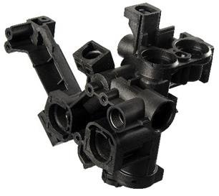

Figure 3 Pictorial representation of the product made from thermoplastic molding materials.

Next, the manufacture of mold is a crucial part of injection molding. This part possesses the actual construction of the mold of the desired shape with the involvement of precise machining and assembly. The mold cost depends upon the size, complexity, and the material selected for the molds. High volume and more complex structure of the molds require more time and expertise, thus raising the cost as well.

A mold looks like the negative of a photograph, which transfers the designed geometry and texture of the surface onto the injection-molded part. The manufacture of the injection mold requires a weighty cost in the startup. The straightforward design, suitable for the small-scale production amount which ranges from 1000 to 10,000 units costs ranges nearly $2000 to $5000. Similarly, the large-scale molds typically capacity of production i.e., 100,000 units or above cost, required the cost of around $100,000 or above.

In recent times, 3D printing materials made the manufacturing of the molds for low-run injection molding i.e., for 100 parts or less. The invention of 3D printing has made the production of small quantities more economically viable than that of past periods.

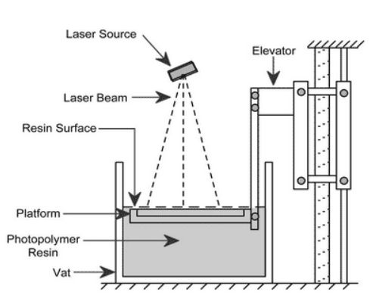

Figure 4 Schematic diagram of the SLA 3D printer

The simplest type of mold manufactured is a straight-pull mold, consisting of two halves i.e., the cavity (front part) and the core (back part). These types of molds are the most chosen in the market due to their design ease and cost-effectiveness. Despite these advantages, straight pull mold comprises certain limitations i.e., part must have 2-dimensional geometry on both sides.

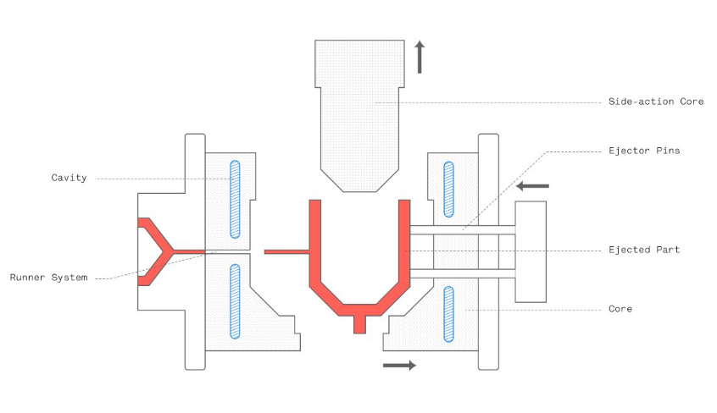

Figure 5 Pictorial representation of the anatomy of the mold.

Further, for more complex geometries retractable side-action cores or other inserts are required. Side actions core enters the mold either from the top or bottom. The side action core must be used with more concern as it raises the cost rapidly. Injection molded parts consist of two sides i.e., A side facing the cavity and B side facing the core. The A side is responsible for the visual appearance and the surface is usually smooth according to the design specifications whereas the B side is the functional side usually hidden consisting of the structural elements.

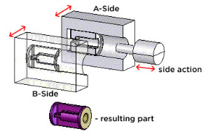

Figure 6 Pictorial representation of the straight pull mold.

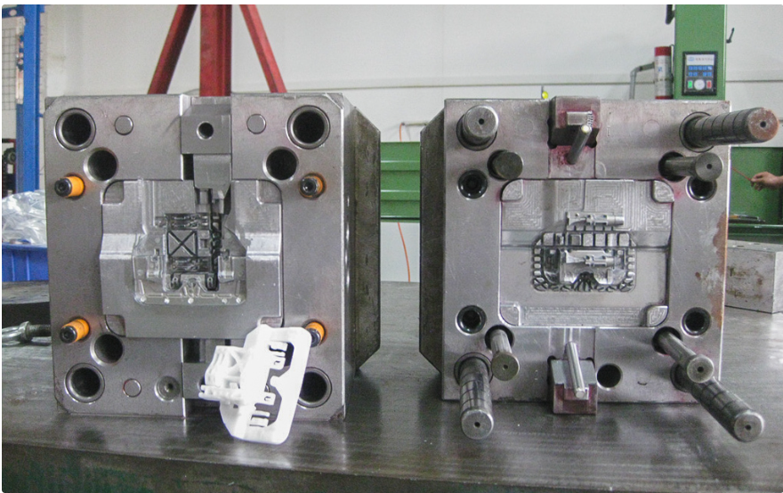

Figure 7 Pictorial representation of the mold of steel in industry.

Lastly, the mold lifespan has an impact on the overall cost of the injection molding. Mold with a long lifespan may have higher upfront costs but it can save the cost for a long time by reducing the problem of short-term maintenance, and timely replacement of the mold. Different factors could increase the lifespan of every mold i.e., regular maintenance, quality of materials, monitoring, etc.

# Production Volumes and Economies of Scale

The fundamental decision that the manufacturers of injection molding face is whether to manufacture products in large volume or small volume. The low-volume production of the products for small and medium-sized production businesses which can produce volumes usually up to 10,000 units or less in a month. The high-volume production in injection molding has a production capacity of 100,000 units in a month. Both low-volume and high-volume production have various advantages which are discussed below:

The advantages of low-volume production are:

1. Less expensive tooling.
2. It allows one to change the design quickly and have design flexibility.
3. It can provide rapid access to the growing markets as it has a short production time.

The advantages of high-volume production are:

1. It can produce the parts in bulk amounts.
2. It will reduce the unit costs and the cycle time for the product.
3. The production is more often automated.

Every manufacturer of injection molding should make the financial viability of their business strategy. The breakeven point will signify the volume of the production from the injection molding in which the total cost of production is equal to the total revenue. In injection molding fixed costs like maintenance and overhead costs remain constant despite production volume. The variable cost changes with the number of productions. Thus, the breakeven point serves as the decision-making point for the manufacturer.

Lastly, per-unit cost considerations are important to the economic analysis of injection molding. The low-volume production will lead to a higher per unit cost of the product manufactured from the injection molding while the high-volume production will lead to the reduction in per unit cost of the product. The various data are analyzed to know the cost associated with injection molding and the per unit cost of the product which is presented below in the tabular form:

Table 2 Cost overview of the different levels of production in injection molding.

|  |  |  |  |
| --- | --- | --- | --- |
|  | Low-volume production | Mid-volume production | High-volume production |
| Production volume | 100 | 5,000 | 100,000 |
| Method | In-house mold production and in-house molding | Outsourced mold production and molding | Outsourced mold production and molding |
| Mold | 3D printed polymer | Machined aluminum | Machined steel |
| Lead time to final parts | 1-3 days | 2-3 weeks | 4-6 weeks |
| Equipment required | 3D printer, desktop injection molding machine | | |
| Mold cost | $100 | $3000 | $20,000 |
| Labor cost | $2.5/part | $0.5/part | $0.5/part |
| Total production cost | $400 | $13,000 | $170,000 |
| Cost per part | $4 | $2.6 | $1.7 |

# Quality and Precision Considerations

In injection molding quality and precision considerations play a pivotal role. The consideration of both the quality of the product and the precision of the product encloses different factors in manufacturing by injection molding. The tool design of the injection molding is the crucial part. The product is designed for manufacture in the best possible way the mold tool can make the product quality difference. For high quality, the product costs can exhibit in various forms, such as higher-grade materials, more advanced machinery, and experts. Although these considerations increase the production costs, they meet the customer expectations and ultimately preserve the reputation and market position.

Next, consistent product quality requires regular and intense inspection and quality assurance processes. The inspection and quality assurance costs are linked up with the manpower, equipment, and time of production. For example, an automobile company producing airbags should implement all the strategies and intense inspections to prevent damage to passenger safety. The costs employed with the advanced inspection tools and experts are added to overall production costs in injection molding. Hereby, the detection of defects early in the manufacturing i.e., inspection and quality assurance process will reduce the risk of company downfall and other possible legal liabilities.

Similarly, the error in injection molding when left unchecked the future result will be vulnerable as it may lead to damage to the company's reputation and prestige. If the faulty product reaches the market and customers experience the poor product then it may tarnish the brand image. The priority on quality and precision in the injection molding process will reduce errors, and financial loss for the company as well. So, learning from real-world manufacturers can make decisions and balance quality and cost-effectiveness.

# Geographic Considerations

Geographic considerations play a pivotal role in the world of injection molding, with the impact of everything from the production cost to the easiness of the supply chain. The injection molding costs vary with the different countries. Countries such as China, and Vietnam have lower labor costs than Western countries, Additionally, raw materials costs, overhead costs, and energy consumption costs differ from one country to another which also differs in the cost of a whole injection molding process. The manufacturers should conduct a comprehensive cost analysis to compete in today’s market.

Similarly, geographic considerations also drive the cost of shipping and logistics in the injection molding process. The key elements for the manufacturing company are markets and suppliers. Longer transporting distance results in an increment in shipping costs, and longer leading times. The easiness in supply to the market will automatically lead to a reduction in cost.

More likely, in today’s world, import/export taxes and tariffs are an important part of costs in injection molding companies. The taxes between countries and tariffs on imported raw materials or finished products change the structure of the cost of the injection molding operation.

# Strategies to Optimize Costs

In the injection molding process, when there is precision and efficiency are at the uppermost level, cost optimization is pivotal which impacts greatly in the company’s revenue. To achieve optimization, several key strategies are discussed thoroughly in this section.

Material selection is the most notable factor that affects the cost of the product in injection molding. The choice of materials is influential in the overall cost management of the company. The high-quality materials may cost high but they result in a long mold lifespan, and fewer defects, thus reducing the overall maintenance cost and replacement cost. But for betterment selecting the cost-effective materials that meet the required functions can reduce the cost. The decision of the right balance between material quality and cost can help a manufacturer in long-term cost savings.

Secondly, designing the molds and parts plays an important role in cost optimization. By adopting design practices that reduce the complexity, reduce the undercuts, optimize the part geometry, and utilize the core cavities efficiently, the manufacturer can reduce the cost as well as the time and resources required by the cycle of production. Further, efficiency in design can minimize material waste which directly reduces the cost of production.

Automation and utilization of advanced technologies are also inseparable from the cost optimization strategy for injection molding. Automated systems are advantageous as the systems operate consistently without halt which leads to high production and reduces labor costs. The adoption of advanced technologies in injection molding i.e., real-time monitoring and predictive maintenance, use of robotics, and AI technologies can minimize unplanned downtime, maintenance costs, rework costs, etc. This adoption of automation and advanced technologies will gain efficiency and long-term cost savings.

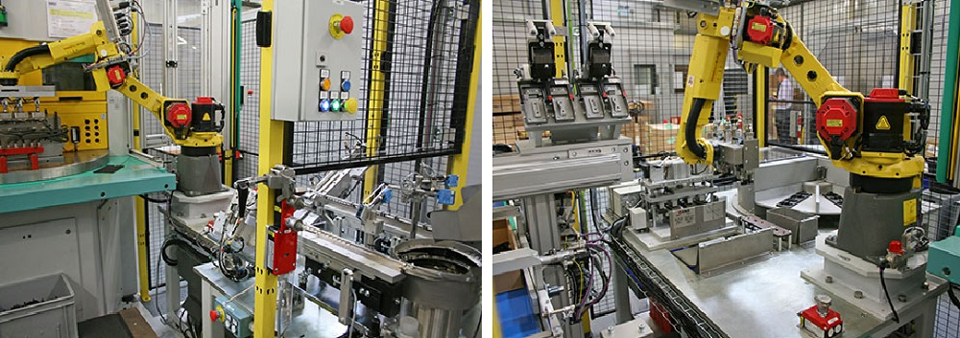

Figure 8 Pictorial representation showing the automated injection molding unit.

# Case Studies

The case study is of Keysight Plastics Molding Ltd. which uses automation for the advancement of injection molding and to expand its business more economically.

The company Keysight Plastics Molding Ltd, an injection molding company of medium-scale, was facing the problem of a highly competitive market and increased production costs. So, to regain its place in the present market, the company decided to optimize its injection molding costs by upgrading its injection molding system with automation and advanced technologies.

After, the company invested in automated robotics systems to optimize their production. The robots are installed to handle cyclical tasks i.e., material removal from the parts, quality inspection and assurance before packing, and finally the packing of the products which finally reduces human errors and reduces production time as well as costs. In addition, the company installed real-time monitoring systems and data analytics tools to analyze the proper use of the material, the performance of the machine, and quality control for all the products produced. This helps the company to polish its product and compete in the market. Furthermore, the automation system helps them to identify the further optimal path for the cost reduction in injection molding. This optimization method helps the company to reduce labor costs, other overhead costs, consistency in product development, etc. This study shows how the traditional molding company utilizes the optimization model to enhance their business of injection molding with the help of new technologies.

# **Conclusion**

In conclusion, understanding the cost breakdown in the injection molding manufacturing companies that are in verse of competing in today’s market is a must. Several factors drive the cost of injection molding. The study shows that factors like fixed costs, variable costs, cost of mold design and tooling, production volumes, economic scales, automized technologies, product quality and consistency, geographic positioning of the company, etc. are the main drivers in deciding whether the costs of injection molding is in the range of the company capacity. Thus, the company should go through an intense cost analysis to identify the exact injection molding costs.

Similarly, this article provides the importance of comprehensive costing for the success of injection molding. This cost will help the company to make decisions at every stage of the production in injection molding to make their business more sensitive. A deep understanding of the cost will help to guarantee that the resources are utilized optimally whether it’s a material selection, production volume planning, or mold design.

Finally, the overall cost of the injection molding is discussed in this article. It suggests the company of injection molding should utilize the strategies to optimize cost with many examples, and also encourage the new business initiator to start the injection molding business with intense cost analysis and uses of advanced technologies. This article also suggests that injection molding companies to be flexible and adapt to the new markets. The business of injection molding is of complex process and consists of many drivers of the cost.